Transforming Your Course with Student Peer Assessment

Lilly San Diego Feb 27-29, 2020 Teaching for Active and Engaged Learning

Presenter: Dr. Amanda Bradley, University of British Columbia, Dept of Pathology & Laboratory Medicine, Senior Instructor & Director, Bachelor of Medical Laboratory Science Program, Vancouver, B.C. Canada
abradley@pathology.ubc.ca

At the end of this session, participants will be able to:
1. Describe at least 4 requirements for student peer assessment to work well (i.e. improving both student learning and perceptions of peer assessment)

2. imagine the disruptions to their course that would occur as a consequence of adding student peer assessment and consider how these disruptions could lead to improved course design overall

3. Integrate lessons learned from a case study into their own plan to successfully incorporate student peer assessment into a course.

Student Peer Assessment
Definition: “the quantitative or qualitative evaluation of a learner’s performance by another learner of the same status” (Patchan & Schunn, 2015)

What are you trying to achieve by having students assess & provide feedback on one another’s work?

When peer assessment requires significant student time and effort, what should we consider for the course?

How can we support & motivate students? How could we further address “fairness”?

Peer Assessment Process
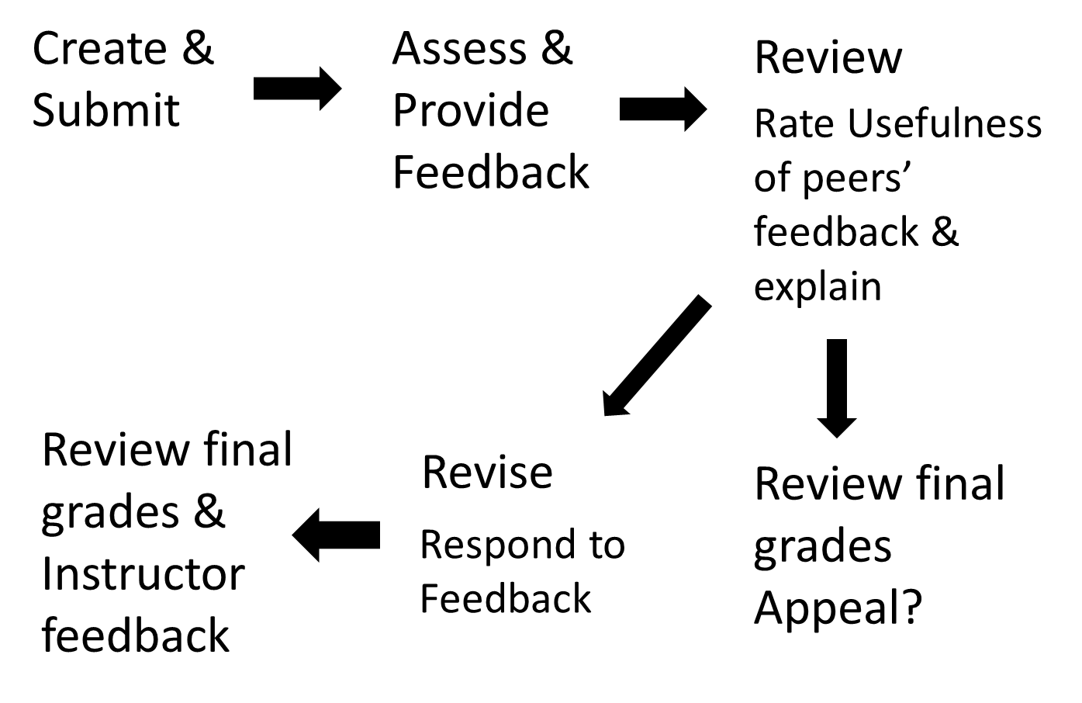
Peer Assessment Tool
There are many ways to implement student peer assessment in your teaching. The tool I chose for my course was PeerScholar https://www.utsc.utoronto.ca/technology/peerscholar

Benefits
Student peer assessment may help students:
- Develop their analytical skills
- Enhance their self-assessment skills
- Augment their reflective abilities
- Increase their level of responsibility and engagement
- Improve the quality of their writing
(Baker, 2016; Burgess & Mellis, 2015, Harland, Wald, & Randhawa, 2016)

Challenges
Some challenges of using student peer assessment:
- Can involve large investment of time up front for instructor
- Students do not consistently respond to the feedback
- Students may award higher marks than instructor
- Students feel poorly equipped to undertake the assessment
- Student frustration: they want marks assigned by instructor
- Students may be reluctant to make judgements regarding their peers
(Baker, 2016; Major, Harris & Zakrajsek, 2016; Schneider, 2015)

Which 1 or 2 ideas will you focus on when you implement or refresh student peer assessment in your course?

Project Team & Funding:
This project was supported by the UBC Teaching Learning Enhancement Fund. Colleagues on the grant & doing other student peer review work:
Alison Greig, Associate Head, Masters of Physical Therapy Program
Anne Rankin, MScPT (retired)
Isabeau Iqbal, Centre for Teaching, Learning and Technology
Amy Ho, Project Assistant

References:
- Nilson, L.B. (2010) Improving Student Peer Feedback. College Teaching, 51:1, 34-38.
- Baker, K. (2016). Peer review as a strategy for improving students’ writing process. Active Learning in Higher Education, 1-14.
- Major, C. H., Harris, M. S., & Zakrajsek, T. (2015). Teaching for learning: 101 intentionally designed educational activities to put students on the path to success. New York, NY: Routledge.
- Patchan, M. M., & Schunn, C. D. (2015). Understanding the benefits of providing peer feedback: How students respond to peers’ texts of varying quality. Instructional Science, 43:5, 591-614.
- Fink, L.D. (2013) Creating Significant Learning Experiences: An Integrated Approach to Designing College Courses
- Burgess, A. & Mellis, C. (2015). Receiving feedback from peers: medical students’ perceptions. The Clinical Teacher, 12(3), 203-207.
- Harland, T., Wald, N., & Randhawa, H. (2016). Student peer review: enhancing formative feedback with a rebuttal. Assessment & Evaluation in Higher Education, 42:5, 801-811.

Creative Commons License: Attribution-NonCommercial 4.0 International

