Creative Student Learning Outcomes
Integrating Academic Identity and Teaching Practice
Shamini Dias • Claremont Graduate University • shamini.dias@cgu.edu

Values and Visions - My Philosophy

- Think of a course you teach and come up with 2 kinds of values and visions based outcomes:
  - Content Outcomes. What do you really want your students to master in your discipline?
  - Capacity Outcomes. What skills and capacities are important to foster in your students to help them flourish in a future that is unpredictable, global, and full of diversity and rapid change?
- Use the three outcomes frameworks in this packet to generate your values and visions - Bloom’s Taxonomy, Fink’s Taxonomy of Significant Learning, and AAC&U’s LEAP Essential Outcomes.
- Write words and phrases to share your Content and Capacity outcomes on the large poster paper in the room. Use the Sharpies to write.

CONTENT OUTCOMES - The Passionate Teacher-Scholar
- My values as a scholar - what brings me joy in my discipline?
- What do I really care about for my students to learn?

CAPACITY OUTCOMES - Future-Focused Ethical Educator. Thinking about a fast-changing, unpredictable, diverse, and global future ...
- What skills and capacities will my students need to flourish?

Bloom’s Taxonomy
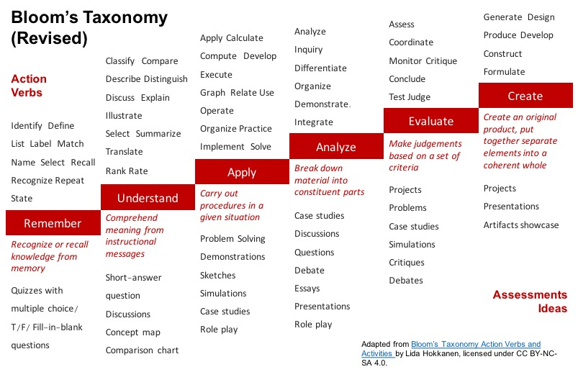

Fink’s Taxonomy of Significant Learning
Foundational Knowledge | Content. Understand and Remember. Basic understanding necessary for other kinds of learning.
Application | Critical, creative, and practical thinking and skills developing. Allows learning to become useful.
Integration | Connecting different things - ideas, events, realms of life (e.g. between school and work, or history and pop art).
Human Dimension | Learning about oneself and others, personal and social/human significance of what one learns. Meaningfulness of classroom content to self and society.
Caring | Developing new interests, feelings, and values associated with the course material. Building connections of meaning and relevance between learning and self.
Learning How to Learn. | Becoming self-directed learners, self-regulation, reflection and metacognition for life-long learning.
AAC&U LEAP Essential Outcomes
https://www.aacu.org/

